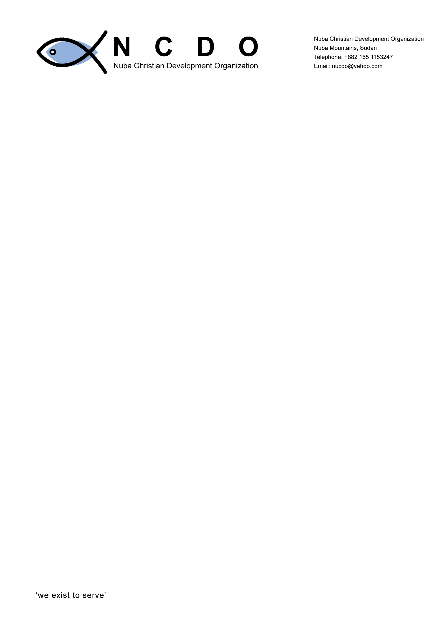

SPECIAL NEEDS EDUCATION CONFERENCE
Report
MAY 10th to 12th 2009

By: JOSEPH MALISH FESTO
NCDO EXECUTIVE DIRECTOR
NUBA MOUNTAINS

Main Theme of the Conference: Exchanging Experiences and Best Practices

Venue: Dr. John Garang Cultural Centre in Julud, Dilling County

Participants: SNE Consultant from Kenya, Head teachers, teachers,
Education Officials, political leaders, religious leaders
and members of the Community in general from
Lagawa, Dilling and Kadugli counties, NCDO members and
other NGO representatives

Chief Guest: Mr. Abdulhamid Haron Tawa, Regional Education
Coordinator Nuba Mountains

Sponsors: IAS in collaboration with Nuba Christian Development Organization
(NCDO)
Annex I List of participants.

Introduction;
The conference was organized as the fourth activity in the partnership time plan. i.e. Sharing experiences and best practices. Prior to the conference, Stephen Mwara, a Kenyan consultant brought in by International Aid Services (IAS) to carry out the survey and train NCDO teachers who later on will train others in Nuba, has carried out a baseline survey in Lagawa and Dilling counties, and in Kadugli county in several schools, NGOS and other relevant government bodies.
The conference drew people from Lagawa and Dilling counties, government officials, NGOS, women leaders, school head teachers, education officers, Village and religious leaders and representatives from the United Nations mission in Sudan (UNMIS).

Objectives of the conference

The main purpose of the conference is to share and exchange experiences and best practices of inclusive and child-friendly practices and to develop recommendations on how to promote more rights-based approaches to education in Nuba Mountains within the framework of Education for All.

The specific objectives are to:

- share experiences and best practices in managing and implementing Special Needs Education in Nuba

- Identify children who are still out of school and discuss what to do to have them enrolled in schools. This includes those with special needs and disabilities.

- identify and discuss barriers that may affect Inclusion of all children in regular schools and how to overcome them
- Receive and discuss the findings of the baseline survey on IE/SNE carried out in Lagawa, Dilling and Kadugli counties in February 2009.

- Develop recommendations on how to improve the education system in Nuba Mountains to ensure that all children including those with special needs and disabilities will get quality education.
Day I
The program commenced at 11: 12 am with prayers from both Christian and Muslim faith. NCDO executive director welcomed and thanked the participants for turning up in a great number. He gave a brief background on IAS experience on special need education in Somaliland and the new project that NCDO wish to undertake in South Kordofan. It is a pioneer project and is expected to draw attention of other players as it expands to other regions.
The education officer for Dilling County on the other hand welcomed the participants to his payam and commented that illiteracy is still a problem in the region, therefore he welcomed the special need education program in Nuba mountains as one of the tools to fight illiteracy.
The Regional education coordinator for English schools Mr. Hamid who was the guest of honor welcomed the participants and gave a general background of education in the former SPLA/M areas.
According to him, education is one of the priorities after the signing of the comprehensive peace agreement (C.P.A) in 2005 but the government did not consider those children with disabilities.
He however thanks NCDO and IAS for taking the initiative to introduce the program in Nuba Mountains.
He further gave the statistics of the existing primary schools and secondary schools as below;
19 primary schools in Dilling county, 08 primary schools in Lagawa county, 72 primary schools in Kadugli county and 129 primary schools in Rashad county. In all, there are 229 primary schools with a total number of teachers being 649 national teachers and about 85 or less expatriate teachers.
There are three English secondary schools in the whole of Nuba. One supported by NCDO in Tima, two in Kauda supported by the diocese of El-Oboid and one supported by one of the expelled NGOs
The education coordinator assured the participants that the government is already aware of the special need program to be introduced by IAS and NCDO and will contribute a maximum support in terms of moral support and any other support that may be available.

KISE consultant: (Given a new name Mr. Kuku; meaning the first born in Tima language) gave the main objectives of the conference being “to share and exchange experiences and best practices of inclusive and child-friendly practices and to develop recommendations on how to promote more rights-based approaches to education in Nuba Mountains within the framework of Education for All”.

Introduction to Special needs.
The consultant introduced what Special need education is and who are the children with special needs. Further more, the causes of disabilities and the barriers of children with disabilities in learning in popular schools.
Causes of disabilities:
- Before birth
- During birth and
- After birth
The above have been explained in details e.g. Taking of drugs (drinking of too much alcohol, smoking and other drugs can affect the child while in the womb, lack of immunization, gun shorts, malnutrition, improper handling of the baby in the process of delivery, accidents among others.

Why children with special needs are not in public schools?

Groups were formed where open discussions were carried out on the above question. Through the discussions, most of the groups came up with the following;
- Some parents in Nuba Mountains are not interested in sending such children to school.
- The communities on the other hand does not have special schools for children with disabilities as such the children are kept at homes
- Lack of government support for disabled children
- Cultural barriers
- Transport problems especially for the lame
- No trained teachers for such children
- Children with special needs are always discriminated and considered of no importance.
- Fear of intimidation by peer group.

However, the groups suggested that;
  - There should be a general awareness of the public on the matter
  - Teachers for special need education should be trained
  - If possible open schools for children with disabilities
  - Children with special needs should not pay school fees to boost their studies
  - transport facilities like wheel chairs should be provided to those who need them
  - counseling should be carried out for such children in other for them to accept themselves as they are and join schools. Further more, normal children should also be encouraged to accept the children with disabilities in the schools

Day II
This day was mainly for reporting of the findings on the survey carried out by the consultant.
The general finding states that, there are many Children with special needs in Nuba Mountains who do not have access to education due to various barriers/challenges.

Some parents are ignorant that such children should be taken to school or they may know but think that educating them is pointless and they thus give priority to the education of the children who do not have special needs.
Other findings include:
- The curriculum does not comprehensively meet the needs of the children with disabilities
- There is a very poor learning environment not only for those with special needs but also those without special needs.
- There is also the problem of the rocky and difficult terrains and long distances from home to the nearest school.
- The school environment in the study areas was found to be discriminatory to the Children with special need because the facilities were not designed with them in mind.
- The findings also revealed that there is inadequate human resource development to support IE/SNE. Most of the teachers are not even trained and hence would find it difficult to assist those with special needs. Indeed one of the major constraints to IE/SNE is the shortage of teachers.

Recommendations
  - There is need to train more primary teachers to fill the gape of lack of enough teachers in the existing primary schools.
  - NCDO/ IAS to bring in more trained teachers from South Sudan or other east African neighboring countries to add on the few expatriate teachers in Nuba Mountains if possible.

This day was marked by the presence of UNMID representatives who came to witness the progress of the conference. The representatives appreciated the initiative of IAS and NCDO in trying to bring in to attention the education of the neglected children. And they further geared a concern for such children and that NCDO/IAS can raise any other issue of interest to them and they would see how to become part of the SNE program that is due to be implemented in Nuba Mountains.

Day III
Barriers to Inclusion:
The participants have been asked to identify some of the barriers to inclusion of children with special needs in Regular schools and suggest ways to overcome them
Barrier How to overcome them
1. Negative attitudes of parents and teachers Hold awareness.
2. Lack of teaching skills among existing teachers train teachers
3. Cultural belief awareness on
importance of
Education
4. Poverty finds a way of free education
5. Sickness Find medication
6. Discrimination equal treatment of children
7. Drug abuse teach them about the
danger of Drugs
8. No schools for special needs open schools.

WAY FORWARD AND OTHER RECOMMENDATIONS.

Below have been suggested as a way forward if SNE program is to succeed in Nuba Mountains
- Training of teachers need to be embarked on seriously to reduce the less ratio of teacher to pupils in the English primary schools.
- Establishment of more schools to reduce the problem of long distance where in some areas, it is estimated that some children walk for over 40 minutes one-way to get to the nearest school.
- Community awareness and sensitization on issues of children with disabilities to be given a priority.
- Establishment of special schools
- Capacity building of PTA members through trainings to help them put into consideration children with disabilities in their schools.
- More water/ boreholes to be drilled in schools to provide children with clean drinking water.
- Assessment centers to be established in all counties to help track all children with disabilities.

